Varun Sai P
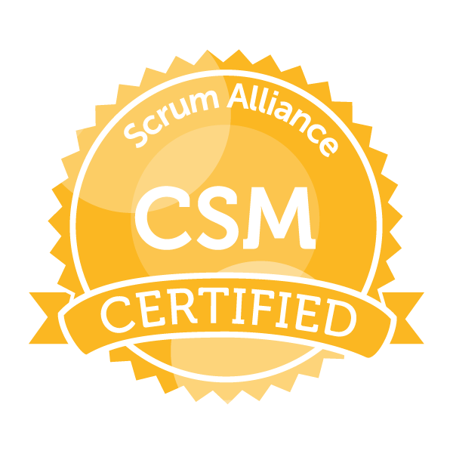
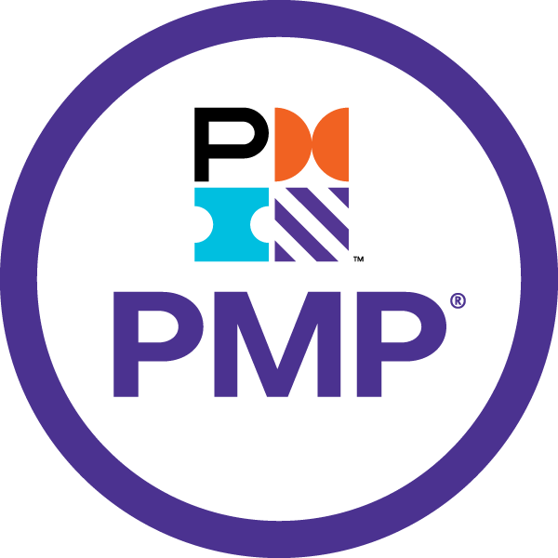
Technical Business Analyst

Email:varunsai201995@gmail.com | 703-953-2230

Professional Summary:
Results-driven Technical Business Analyst with over 9 years of experience leading IT projects, managing cross-functional teams, and aligning technical solutions with business objectives. Expertise in Agile, Waterfall, and SDLC methodologies, with a proven track record of delivering complex software projects on time and within budget.
- Experienced in different Software Development Methodologies like Scrum, Waterfall, Water-Scrum-fall Hybrid, also have fair understanding of other industry standard methodologies like SAFe.
- Successfully led cross-functional teams and bridged the gap between business stakeholders and technical teams, ensuring technical solutions aligned with organizational objectives and delivered measurable value.
- Skilled in eliciting, analyzing, and documenting requirements using techniques such as Interviews, JAD Workshops, Document Analysis, Prototyping, and Focus Groups, ensuring alignment with business goals.
- Proficient in facilitating Sprint Ceremonies (Sprint Planning, Daily Scrum, Sprint Review, Retrospective) and creating user stories using INVEST criteria, enabling effective backlog prioritization through Moscow and KANO models.
- Experienced in creating UML diagrams (Use Cases, Activity, Sequence, Data Flow, ER) using tools like MS Visio and Balsamiq, assisting in Business Process Modeling and system design.
- Adept at performing GAP Analysis, SWOT Analysis, and Impact Analysis to transition from AS-IS to TO-BE systems, improving efficiency and performance.
- Strong expertise in Agile Development Methodologies (Scrum, Kanban) and hybrid models (Water-Scrum-fall), coaching teams on Agile processes and producing daily burndown charts to track progress.
- Skilled in User Acceptance Testing (UAT) by preparing detailed test scenarios, reviewing test cases, and guiding end-users to ensure system functionality aligns with business expectations.
- Successfully managed multiple Agile teams (Scrum and Kanban), coaching team members on Agile best practices, fostering cross-team collaboration, and delivering consistent project outcomes with measurable success.
- Experienced in defining and implementing data validation frameworks to ensure accuracy and consistency of critical business data across systems and workflows.
- Delivered actionable insights through the development of KPI dashboards and data visualizations using tools like Power BI, enabling stakeholders to make informed decisions.
- Proactively identified and mitigated risks during project execution, ensuring projects were delivered on time, within scope, and exceeded business objectives.

Professional Experience

Asurion - Sterling, VA January ‘23 – Current
Sr. Technical Business Analyst
Project: ServiceBench Mobile and Web Application Implementation for HomeserveUK
KeyAccomplishment: Successfully served as the primary point of contact for client management, ensuring on-time delivery of a bug-free, customized mobile and web application. Oversaw end-to-end production support, project budgeting, scoping, planning, and milestone tracking, ensuring successful project completion while meeting customer satisfaction goals.
- Led cross-functional teams across geographically dispersed locations (Development/QA – Philippines, India; Client – United Kingdom; DevOps – United States, Philippines) to deliver high-impact solutions, ensuring seamless project execution and on-time delivery
- Managed the API integration process, working extensively with Postman, AWS (SQS, EC2, EKS, S3) to ensure robust data exchanges between mobile apps and backend systems.
- Led end-to-end mobile app deployment for both iOS and Android platforms, managing Google Play, Apple Store, and MS App Center submissions, while ensuring compliance with platform guidelines.
- Conducted gap analysis to identify opportunities for leveraging existing product functionality, enabling the client to optimize budget and prioritize critical features.
- Monitored project performance metrics using New Relic dashboards to track API performance, logs, error rates, and system health checks, ensuring minimal disruptions and optimal performance.
- Collaborated closely with stakeholders to align technical deliverables with business objectives, translating business requirements into actionable project plans.
- Developed and managed project schedules using Agile methodologies, leading sprint planning, backlog prioritization, and retrospectives, ensuring continuous improvement and delivery within budget and scope.
- Produced detailed Power BI reports to provide leadership with comprehensive insights into project status, challenges, and resource allocation, driving transparency and informed decision-making.
- Proactively identified risks, removed impediments, and implemented corrective actions to ensure projects stayed on track, meeting both client and internal expectations.
- Mentored junior Project Managers, imparting best practices in delivery, risk management, and stakeholder communication to ensure consistent high-quality outcomes.
- Conducted root cause analysis for system issues, collaborating with technical teams to resolve bugs and implement performance improvements, enhancing system reliability.
- Delivered impactful client-facing presentations and product demos, effectively showcasing customizations and securing stakeholder buy-in, while leading end-user training and documentation efforts.
- Led training and documentation efforts for end users, authoring technical documents, coordinating training sessions, and ensuring proper knowledge transfer to the client’s team.

Paradies Lagardere -Atlanta, GA October‘21–December‘23
Sr. Business System Analyst
Responsibilities:
- Acted as the primary bridge between business stakeholders and technical teams, ensuring that business requirements were effectively translated into technical solutions and that technical challenges were communicated clearly to business users.
- Designed and documented requirements for a unified mini-ERP system integrating catalog, inventory, pricing, orders, shipping, and payment functions to streamline operational workflows.
- Defined functional requirements for advanced inventory tracking, including real-time stock updates, automated reordering thresholds, and integration with external sales channels.
- Spearheaded the requirements gathering and documentation process for Dining Management Systems, integrating catalog, inventory, pricing, orders, shipping, payment, and restaurant-specific processes.
- Designed and optimized workflows for inventory management, enabling real-time stock tracking, automated reordering, and seamless integration with external sales channels and restaurant operations.
- Defined comprehensive business and functional requirements for purchase order management, recipe management, and production processes, improving operational efficiency for both eCommerce and dining operations.
- Collaborated with development teams to implement API integrations across platforms, ensuring data synchronization for orders, payments, and inventory across eCommerce, dining, and external systems.
- Developed detailed business rules and processes for dynamic pricing strategies, promotion management, and theoretical cost/yield management, supporting both retail and restaurant operations.
- Created and deployed KPIs and Power BI dashboards, offering actionable insights into order fulfillment, inventory turnover, sales performance, waste management, and operational efficiency.
- Documented and implemented workflows for waste management, vendor management, and TCPOS systems, ensuring compliance with operational standards and improving resource utilization.
- Conducted risk analysis and proactively mitigated project risks by addressing scope changes, resource variances, and technical challenges, ensuring successful project delivery on time and within budget.
- Facilitated cross-functional collaboration among globally dispersed teams to align technical solutions with business objectives, delivering value-driven outcomes for stakeholders.
- Led troubleshooting efforts, supporting key business applications, and continuously evaluating emerging technologies to drive process improvements and adopt best practices in omnichannel and dining operations.

Bank of America – Herndon, VA August‘19–September‘21
Technical Business Analyst
- Facilitated the implementation of workflows for trading and securitization processes in the secondary mortgage market, ensuring compliance with investor guidelines and regulatory standards.
- Defined functional and technical requirements for integrating mortgage-backed securities (MBS) processes with existing systems to streamline pooling, pricing, and settlement activities.
- Translated business needs into functional and technical requirements for custom model development, data filtering, and policy compliance workflows.
- Worked closely with the development team to design and implement optimized processes for monitoring and preventing policy violations.
- Validated data flows and transformation logic within stored procedures and integration channels to maintain data integrity and consistency.
- Facilitated discussions between business users and developers to refine integration channels, active table flows, and outgoing distribution templates.
- Supported user acceptance testing (UAT) by preparing test scenarios, reviewing test cases, and ensuring alignment with business expectations.
- Collaborated with QA teams to validate the accuracy of data filtering, storage, and compliance workflows across the application.
- Prioritized and managed the product backlog to align with project goals and business objectives.

Anthem - Richmond, VA September ‘17 – July ‘19
Business Analyst
- Collaborate with stakeholders to elicit, analyze, and document business and system requirements for healthcare projects.
- collect and analyze data to identify trends, insights, and areas for improvement within the organization.
- Identify inefficiencies in business processes and develop solutions to enhance productivity and effectiveness.
- Communicate effectively with stakeholders to ensure their needs and expectations are met.
- Assist in the implementation of business solutions, ensuring they align with organizational goals.
- Develop test plans and conduct testing to ensure new systems and processes meet requirements.
- Analyze and optimize the claims processing workflow to improve efficiency and reduce processing time.
- Ensure that all claims processing activities comply with regulatory requirements and internal policies.
- Develop and generate reports on claims processing metrics to monitor performance and identify issues.
- Continuously seek ways to improve the claims process, reducing errors and enhancing customer satisfaction.
- Identify potential risks in the claims process and develop strategies to mitigate them.
- Create detailed functional specifications to guide the development of new systems and processes.
- Provide training and support to users to ensure they can effectively use new systems and processes.
- Continuously seek ways to improve business processes and systems to drive organizational success.

CGI Information Systems and Management Consultants, IndiaMay’16– August’17
Jr. Business Analyst
- Involved in all phases of Development life cycle and responsible for creating the Entity-Relationship diagrams, Class diagrams, Sequence diagrams and Flow diagrams and documenting the project architecture
- Managed the full implementation of the project involving requirements gathering and analysis, development, testing and implementation
- Interacted with Business Owners to identify business system needs, evaluated solutions for business problems and proposed alternate methods to increase efficiency
- Developed Use Cases/diagrams, conceptual model, behavior diagrams (sequence, collaboration, state chart, Activity), using MS Visio
- Conducted GAP Analysis and formulated the TO-BE features based on the business requirements and pain points
- Involved in preparing the Database design and Product requirement document
- Performed check for coding standards and code review for the application code

Education
- Bachelor of Technology, Information Systems, Christ University, INDIA

Skills and Expertise
- Project Management: Agile, Waterfall, Scope Management, Risk Mitigation, SDLC
- Business Analysis: Requirements Gathering, Process Improvement, Gap Analysis, Stakeholder Management
- Technical Skills: AWS (EC2, S3, Lambda), Azure Cloud, Python, SQL, JIRA, Confluence, API Integrations, Postman
- Data: Data Analysis, Data Engineering, Tableau, Power BI, DataVisualization techniques
- Tools: MS Project, SharePoint, MySQL, Oracle, New Relic
- Leadership: Cross-functional Team Leadership, Client Engagement, Vendor Management
- Certifications: PMP, Certified Scrum Master (CSM)

Active Certifications
- Certified Scrum Master | Scrum Alliance
- Project Management Professional |Project Management Institution

